How to upload web api in table

1. Go to azure data factory
2. Create pipline
3. Create web activity as create previously
4. Copy it to adls using another web activity as we did previously do each and evry steps did previously

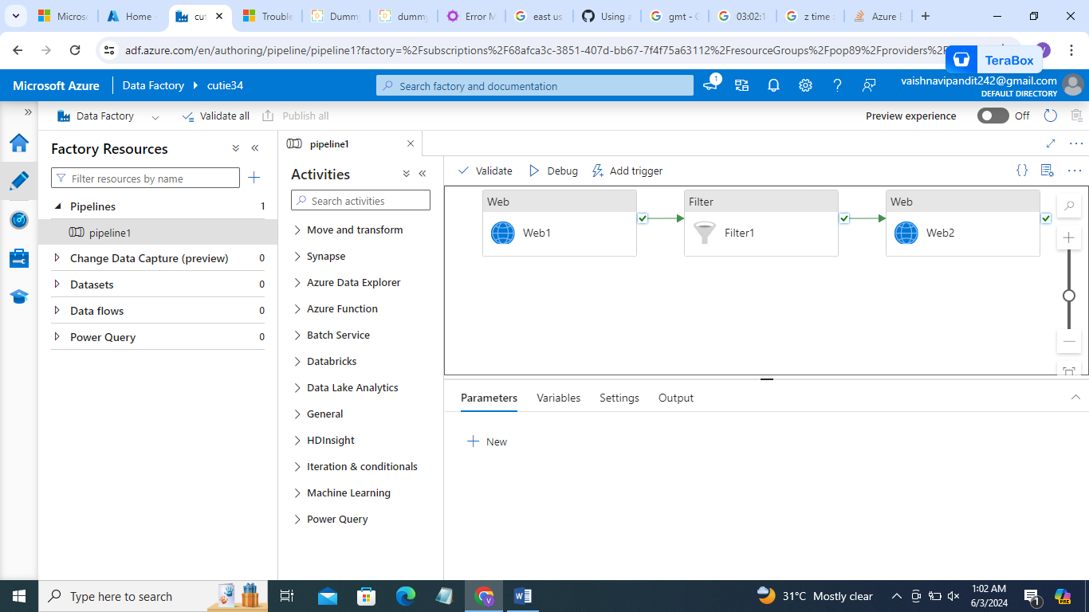

1. Now create dataflow source adls data and

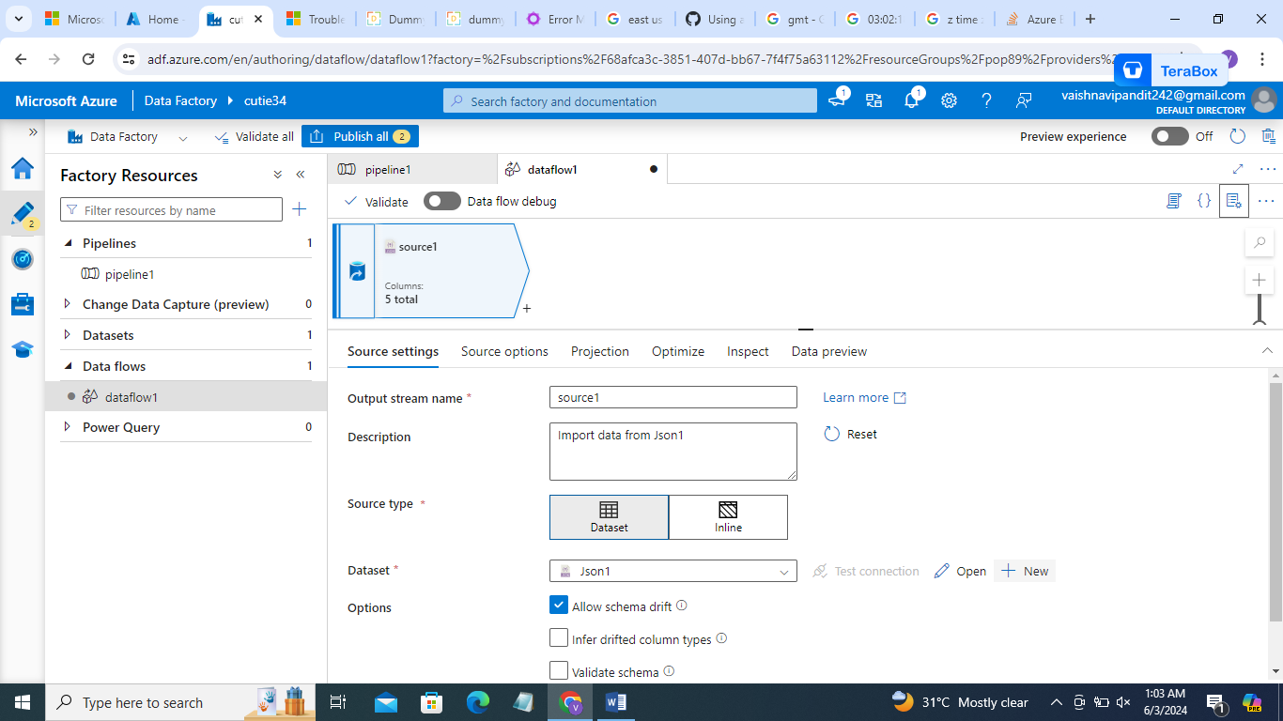

1. In sink crate table

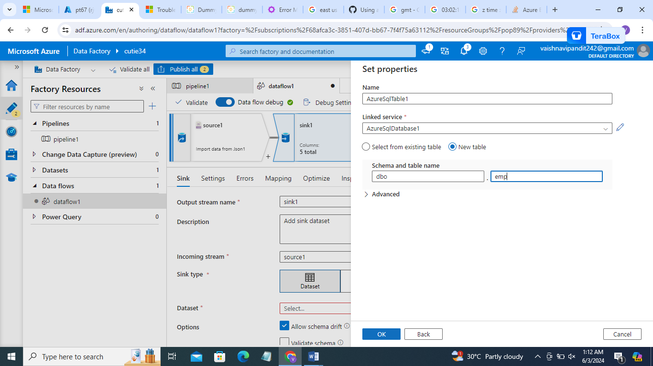

1. Now add dataflow to pipeline
2. debug